ACED Centre Deputy Directors

Summary of Role

The ACED Deputy Directors are responsible for providing leadership across the Alliance, supporting the Directors in decision making for the Alliance, attending all ACED Executive Board (AEB) meetings and deputizing in their absence. These positions will maintain awareness and oversight of all ACED activities across the three portfolios of Research, Infrastructure and Training working collaboratively with the rest of the Alliance Leadership including the Directors of Research and Training, the Executive Board and the Operations Board. The Deputies report to the Centre Directors.

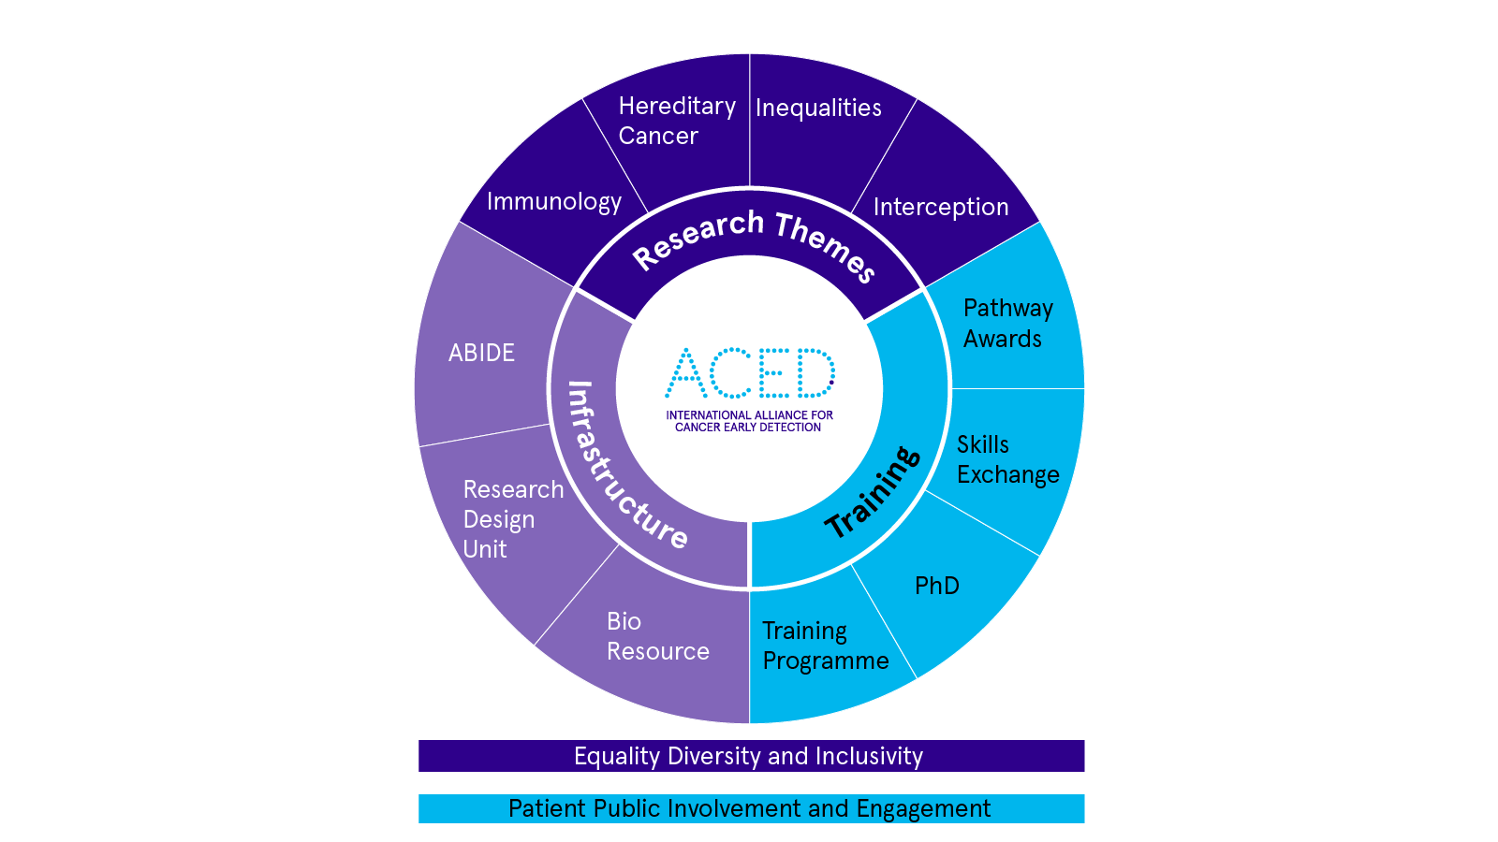

The remit of the ACED Deputy Directors is to:

1. Attend all Executive Board meetings reviewing pre-reads and supporting the Directors with strategic decision making for the Alliance, including representing the Centre Director in their absence.
2. Support the delivery of Alliance objectives by providing strategic leadership and making recommendations to the ACED Executive Board and others as appropriate.
3. Maintain an overview of the ACED Research, Training and Infrastructure portfolios ensuring that the correct information is presented at board meetings to facilitate informed decision making
4. Identify improvements to the Alliance and proposed recommendations to maximise benefit and output in accordance with the overarching strategy.
5. Lead on strategic initiatives as appropriate.

Responsibilities

1. Maintain a collaborative approach, building relationships at all levels across ACED.
2. Attend all ACED Executive Board meetings, deputising for the Directors in their absence including voting on decisions where appropriate. For clarity there is one vote per director that is transferred to the deputy in their absence.
3. Maintain oversight of ACED initiatives (Research, Training and Infrastructure), ensuring that the Directors of these portfolios provide the necessary leadership and information and support to the Executive Board.
4. Maintain oversight of the Research portfolio and outputs, developing an understanding of the breadth of ACED research identifying strengths, gaps, and potential opportunities.
5. Work with the Directors of Research to ensure regular progress reports are conducted with opportunities for future projects internally and externally to ACED identified and supported
6. Ensure delivery of ACED Infrastructure and Training portfolios maintaining oversight and ensuring regular progress reports are provided to the Executive Board.
7. Contribute to funding decisions providing scientific and strategic input to support the Directors in informed decision making.
8. Contribute to the development and delivery of a programme of scientific meetings, seminars and symposia, with organisational support from the ACED Ops board.
9. Encourage engagement and foster interaction between researchers, working groups, students and interested parties within ACED across all Centres and career stages.
10. Represent ACED externally as appropriate
11. Promote harmony and synergy across ACED activities and remain aware of the international scientific landscape.
12. Make strategic recommendations to the AEB in the delivery of the Alliance strategy.

Commitment & Governance

The role is anticipated to require approximately one day per month for activities including but not limited to:

* Attend quarterly AEB meetings throughout the year
* Attending regular joint Deputy Director meetings at a frequency determined by the Deputy Directors.
* Regular review of research progress and update with the Directors of Research and ACED Ops Board, at least every six months.
* Recommend seminars, workshops, and other events across the ACED Research Portfolio working with the Ops Board to coordinate and deliver.

Appointed post holders will be entitled to use the honorary title of ‘ACED Deputy Director’ as appropriate for the duration of their post, as determined by the AEB. The role will be on a 5-year basis to coincide with the length of the quinquennium funding, subject to AEB approval.

The Directors will have the freedom to operate within their role at their discretion however they feel is most effective for the research portfolio, remaining accountable to the AEB. Directors will be expected to demonstrate, where possible, scientific rigour and promote equality, diversity and inclusion in their associated activities with this role.