ACED Directors of Research

Summary of Role

The Directors of Research are responsible for providing oversight and fostering interaction across the ACED funded research portfolio. In addition to the four new research themes (Immunology, Hereditary, Inequalities and Interception), the Alliance has a broad research portfolio comprising of pilot, projects and programmes. The three Directors of Research will work collectively to oversee the whole spectrum of research from basic discovery through to clinical implementation. The Directors will facilitate identifying synergies across the portfolio and supporting research teams to identify further research opportunities. This may include, but not limited to, integration into one of the themes, securing external funding or facilitating new collaborations combining synergistic projects where appropriate. The Directors will report to the ACED Executive Board (AEB) on the progress and outcomes of research and advise the AEB as to results, challenges, and opportunities. The Directors will be supported by the ACED Operations (Ops) Board, Deputy Directors, as well as any other ACED groups such as the Research Design Unit as appropriate.

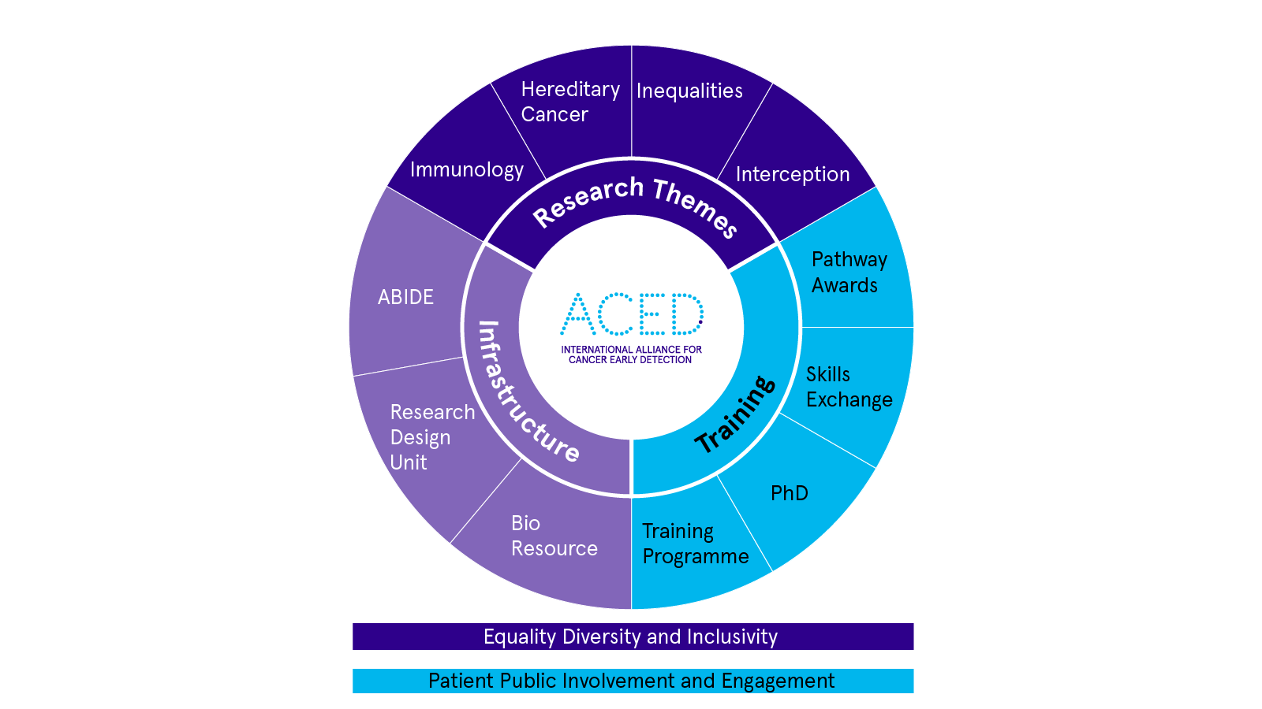

The remit of the ACED Directors of Research is to:

1. Maintain an overview of the ACED research portfolio as it aligns with larger strategic priorities and the intersection between ACED and the wider early detection research landscape.
2. Identify potential synergies across ACED funded research, championing collaboration, and supporting the advancement of ACED research into future funding applications internally and externally to the Alliance.
3. To encourage engagement and interaction between researchers and to encourage new collaborations across the portfolio and the wider ACED research community.
4. Advise the ACED Executive Board on research progress and outputs to support informed decision making.

Responsibilities

1. Maintain oversight of the Research portfolio, developing an understanding of the breadth of the ACED research identifying strengths and gaps in ACED research expertise.
2. Identify synergies and future opportunities for ACED funded research. Where appropriate facilitate advancement of research projects by encouraging collaboration between research teams, identifying overlap with the research themes. or supporting securing external funding utilising the ACED Research Design Unit to appropriately design the study to maximise outputs.
3. Regularly review the progress of ACED funded research with the ACED Ops Board on a six-monthly basis, reporting progress and outputs to the AEB.
4. Lead on the development of a programme to support ACED researchers including scientific meetings, seminars and symposia, with organisational support from the ACED Ops board.
5. Encourage engagement and foster interaction between researchers within the scope of the portfolio across all Centres and career stages.
6. Promote harmony and synergy across ACED research activities and remain aware of the international scientific landscape.
7. Make strategic recommendations to the AEB to deliver the Alliance strategy.

Commitment & Governance

The role is anticipated to require approximately half a day per month for activities including but not limited to:

* Reporting at quarterly AEB meetings throughout the year.
* Attending regular joint Director meetings at a frequency determined by the Directors.
* Regular review of research progress and update with the ACED Ops Board, at least every six months.
* Recommend seminars, workshops, and other events across the ACED Research Portfolio working with the Ops Board to coordinate and deliver.

Appointed post holders will be entitled to use the honorary title of ‘ACED Director of Research’ as appropriate for the duration of their post, as determined by the AEB. The role will be initially fixed term for 2 years to be extended subject to AEB approval.

The Directors will have the freedom to operate within their role at their discretion however they feel is most effective for the research portfolio, remaining accountable to the AEB. Directors will be expected to demonstrate, where possible, scientific rigour and promote equality, diversity and inclusion in their associated activities with this role.